Learnify Application Screens & Features

# **Introduction**

Learnify is an online learning platform offering short IT courses. This document provides an overview of the application's screens and their functionalities. Each section describes the purpose, features, and navigation flow of the respective screens.

# **Application Screens**

## **Home Page**

**Purpose**: Serves as the welcome screen of the app.  
 **Features**:

* "Get Started" button (navigates to the Courses screen)
* Carousel displaying images of the platform
* Navbar with sections of our platform
* A Footer section with necessary information

**Navigation**:

* Clicking "Get Started" → **Courses Page**
* Clicking "Login" → **Login/Register Page**
* Clicking “Explore courses” → **Courses Page**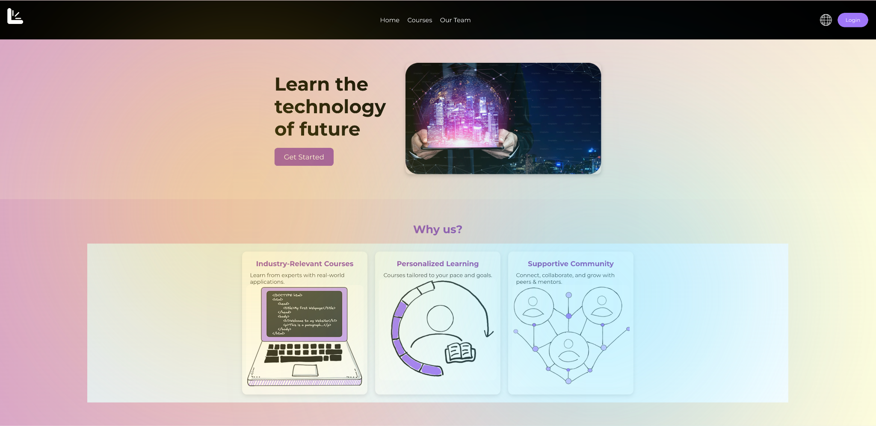

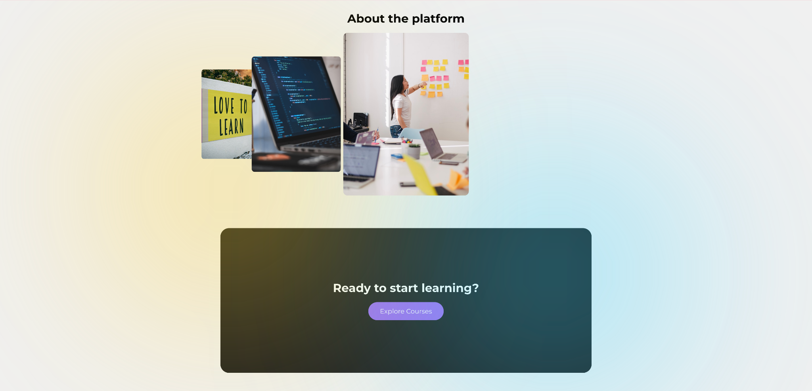



## 

## 

## 

## 

## 

## 

## 

## 

## 

## 

## **Courses Page**

**Purpose**: Displays available courses.  
 **Features**:

* List of courses with details
* Clicking a course navigates to **Course Detail Page**

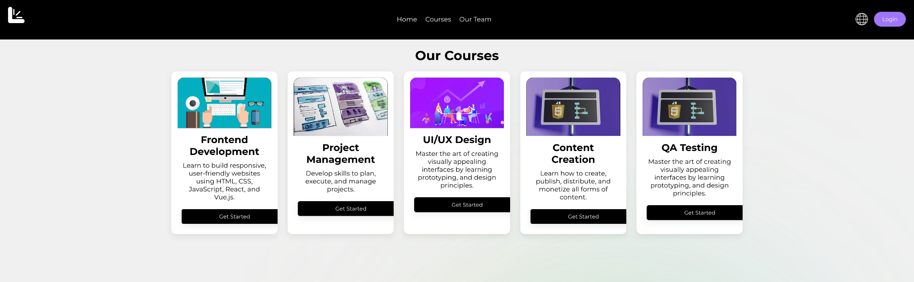

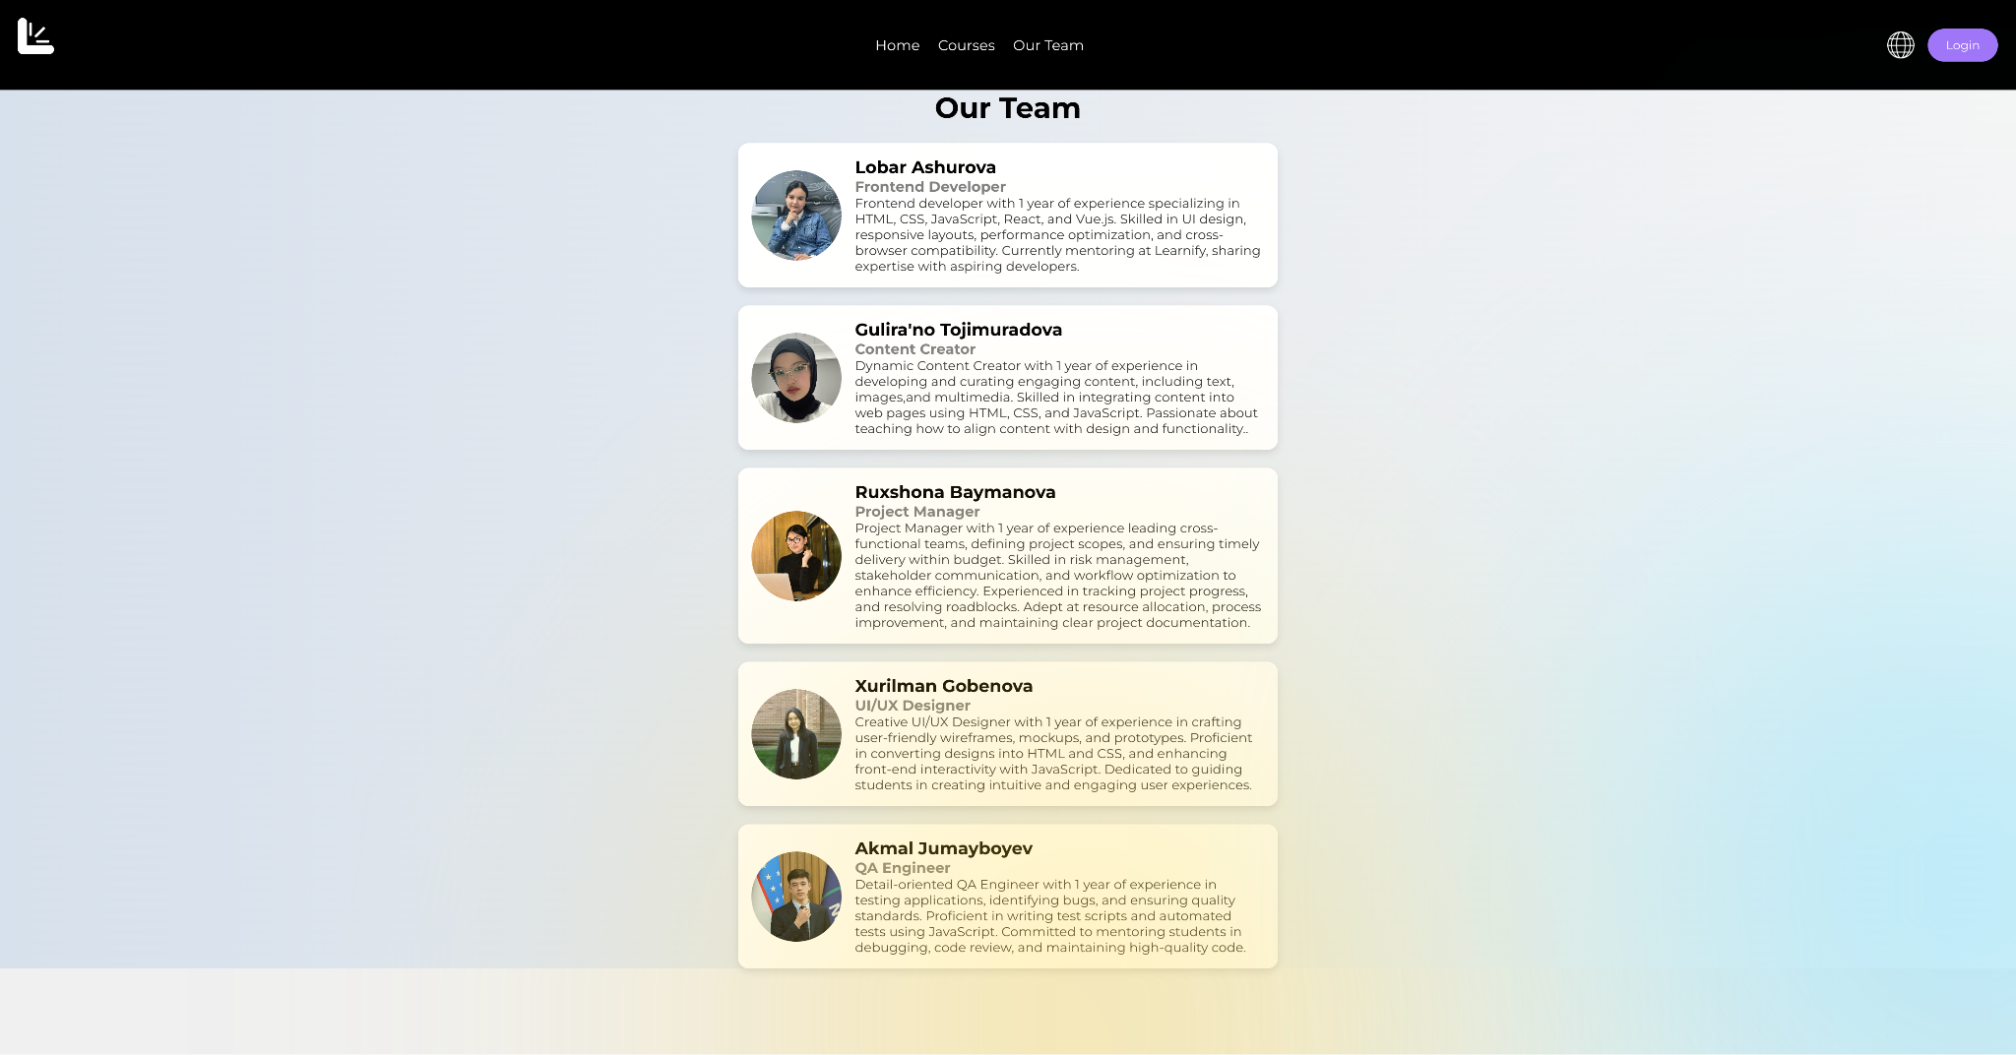

## 

## 

## 

## 

## 

## **Course Detail Page**

**Purpose**: Provides detailed information about a selected course.  
 **Features**:

* Course title, description, instructor info
* "Enroll" button

[image]

## **Login Page**

**Purpose**: Allows users to log in.  
 **Features**:

* Email & password input fields
* "Forgot Password" link (navigates to Forgot Password Page)
* "Register" link (navigates to Register Page)

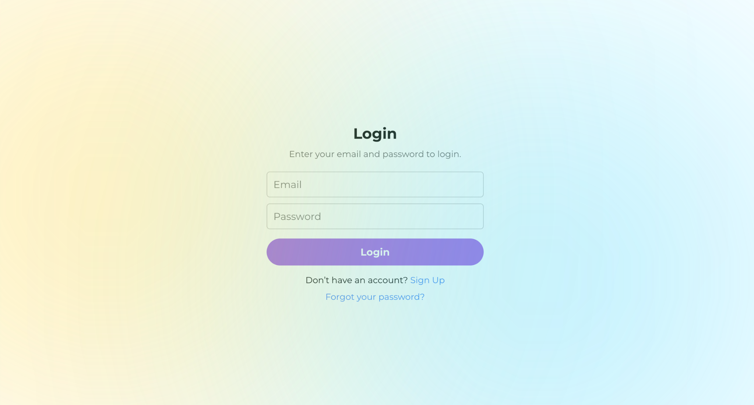

## 

## 

## 

## 

## 

## **Register Page**

**Purpose**: Enables users to create an account.  
 **Features**:

* Input fields for name, email, password, and other details
* "Submit" button (navigates to Verification Page)

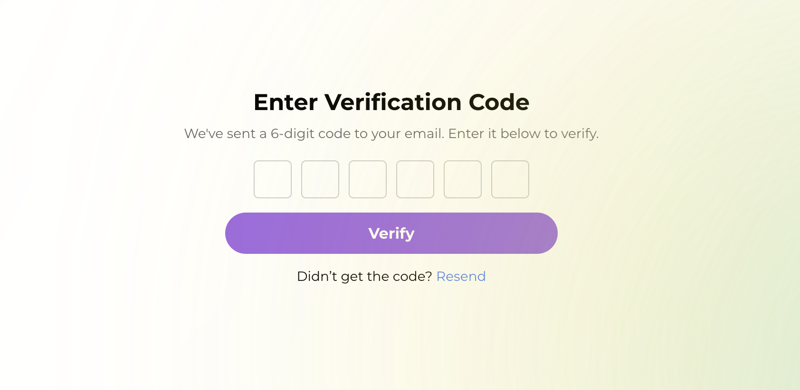

## 

## **Verification Page**

**Purpose**: Confirms user's email verification when user forgets password  
 **Features**:

* Code input field
* "Submit" button to complete registration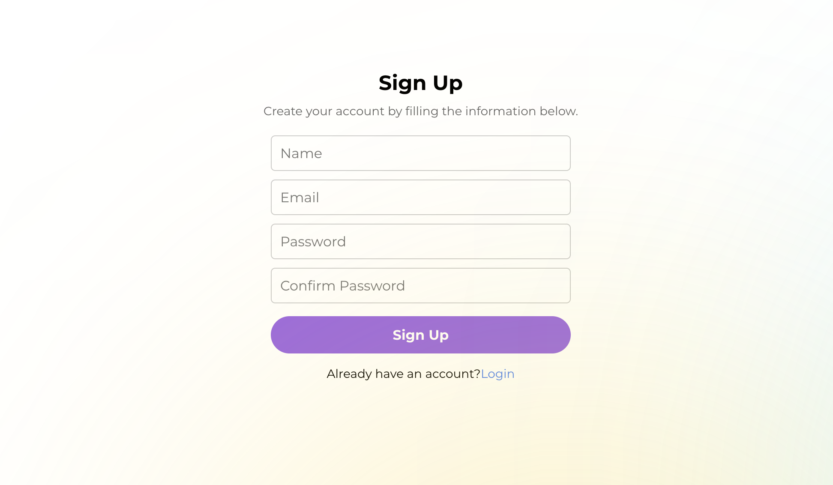

## **Profile Page**

**Purpose**: Displays user profile information. It is a dropdown where user can see three options:

* My profile
* My courses
* Logout

**Features**:

* User’s personal information (name, email)
* Enrolled courses
* Progress bar
* "Edit Profile" button
* “Save” button

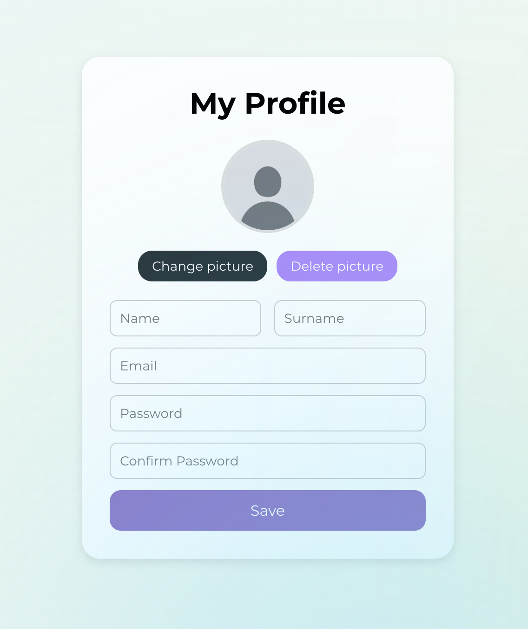

## **Mentors Page**

**Purpose**: Displays available mentors.  
 **Features**:

* List of mentors with their profiles

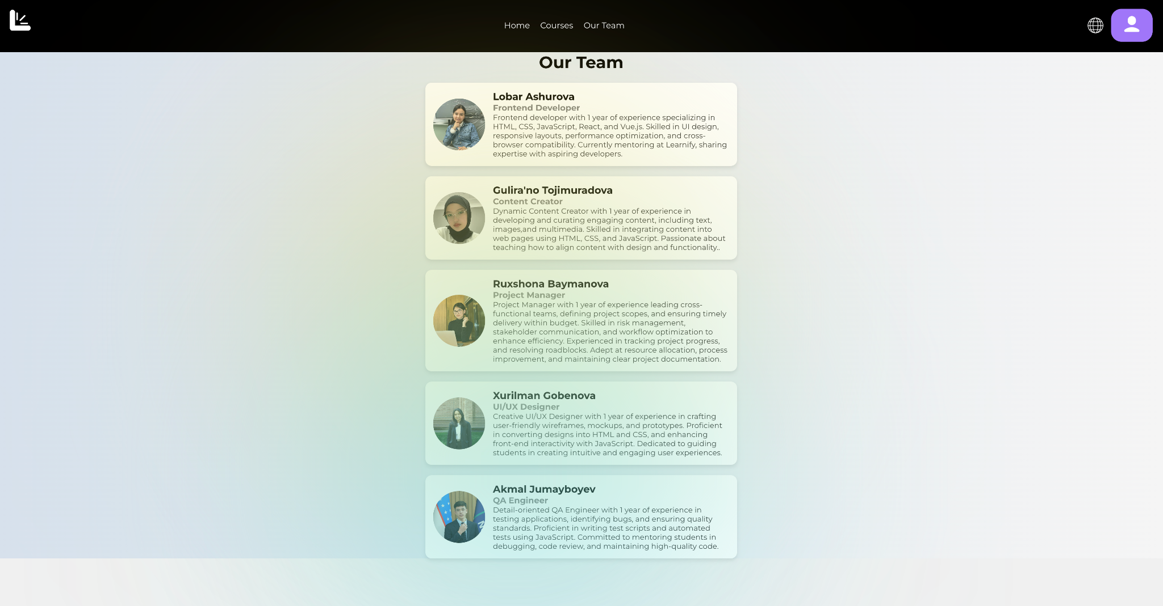

## **Forgot Password Page**

**Purpose**: Allows users to reset their password.  
 **Features**:

* Input field to enter email
* "Submit" button sends reset instructions

